AKS Storage - Azure Files

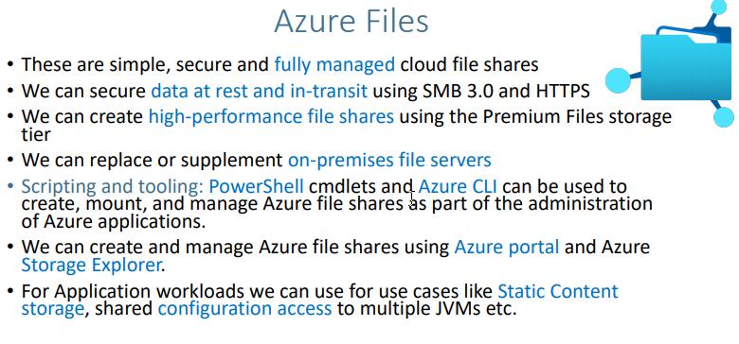

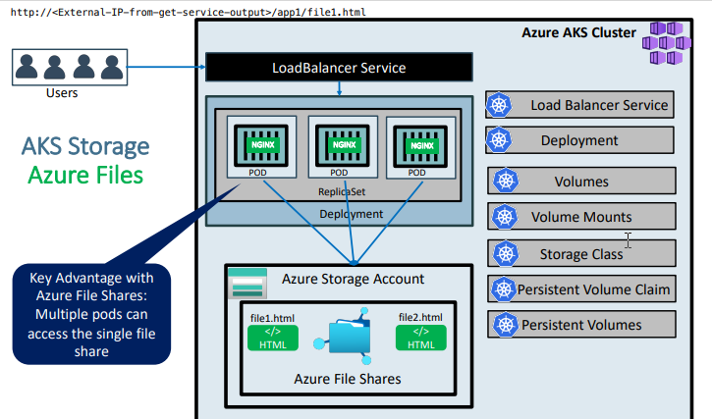

**Azure Files for AKS Storage**

**Step-01: Introduction**

* Understand Azure Files
* We are going to write a Deployment Manifest for NGINX Application which will have its static content served from **Azure File Shares** in **app1** folder
* We are going to mount the file share to a specific path mountPath: "/usr/share/nginx/html/app1" in the Nginx container

**kube-manifests-v1: Custom Storage Class**

* We will define our own custom storage class with desired permissions
  + Standard_LRS - standard locally redundant storage (LRS)
  + Standard_GRS - standard geo-redundant storage (GRS)
  + Standard_ZRS - standard zone redundant storage (ZRS)
  + Standard_RAGRS - standard read-access geo-redundant storage (RA-GRS)
  + Premium_LRS - premium locally redundant storage (LRS)

**kube-manifests-v2: AKS defined default storage class**

* With default AKS created storage classes only below two options are available for us.
  + Standard_LRS - standard locally redundant storage (LRS)
  + Premium_LRS - premium locally redundant storage (LRS)
* **Important Note:** Azure Files support premium storage in AKS clusters that run Kubernetes 1.13 or higher, minimum premium file share is 100GB

**Step-02: Create or Review kube-manifests-v1 and Nginx Files**

* Kube Manifests
  + 01-Storage-Class.yml

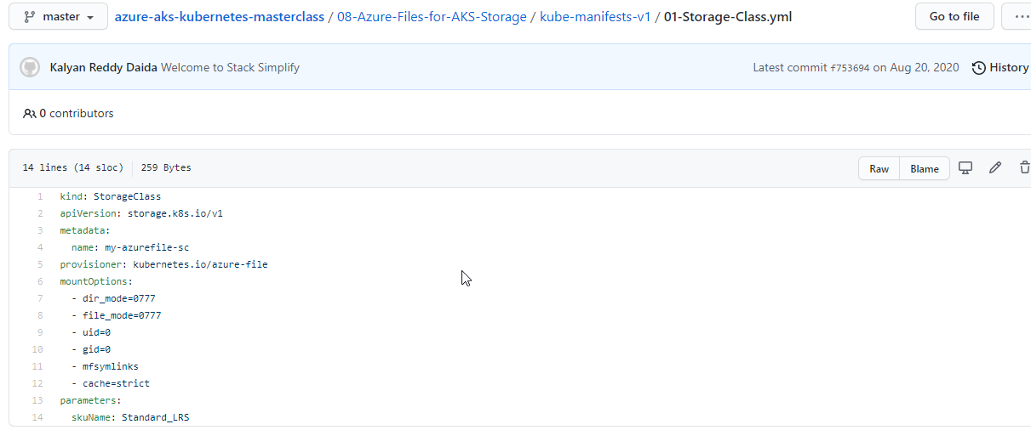

* + 02-Persistent-Volume-Claim.yml

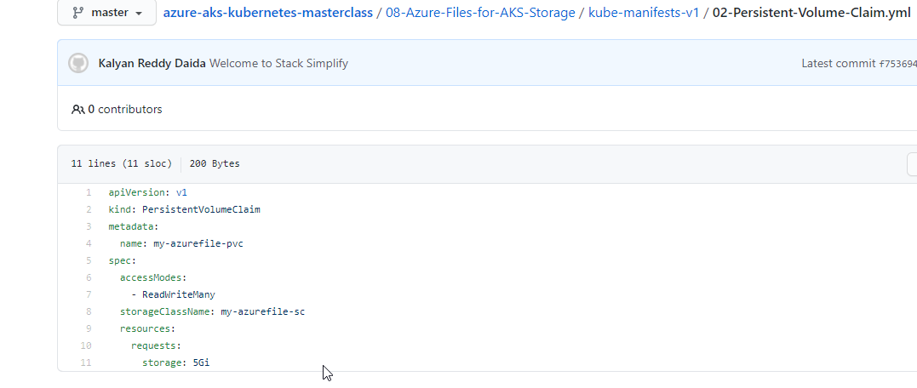

* + 03-Nginx-Deployment.yml

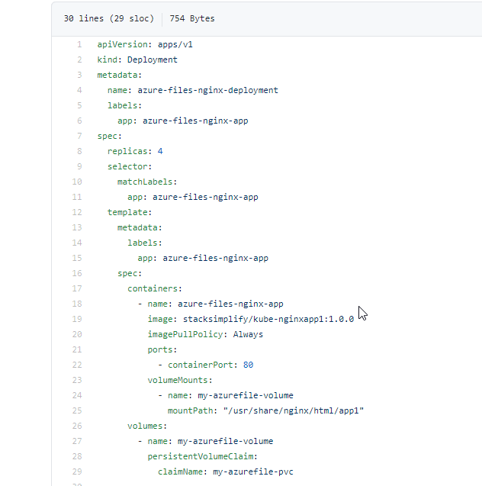

* + 04-Nginx-Service.yml

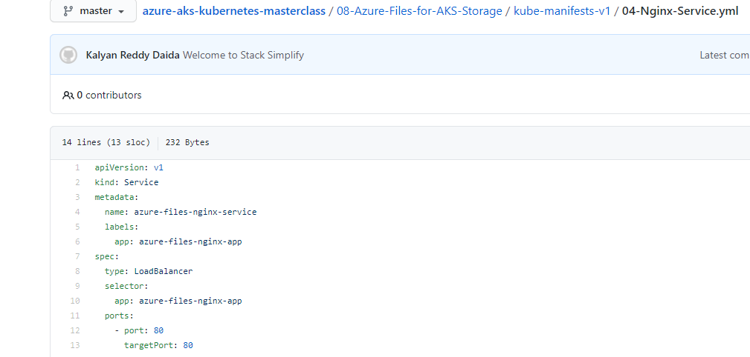

* nginx-files
  + file1.html
  + file2.html
* k8s Deployment maniest - core item for review

volumeMounts:

- name: my-azurefile-volume

mountPath: "/usr/share/nginx/html/app1"

volumes:

- name: my-azurefile-volume

persistentVolumeClaim:

claimName: my-azurefile-pvc

**Step-03: Deploy Kube Manifests V1**

# Deploy

kubectl apply -f kube-manifests-v1/

# Verify SC, PVC, PV

kubectl get sc, pvc, pv

# Verify Pod

kubectl get pods

kubectl describe pod <pod-name>

# Get Load Balancer Public IP

kubectl get svc

# Access Application

http://<External-IP-from-get-service-output>

http://<External-IP-from-get-service-output>/app1/index.html

**Step-04: Upload Nginx Files to Azure File Share**

* Go to Storage Accounts
* Select and Open storage account under resoure group **mc_aks-rg1_aksdemo1_eastus**
* In **Overview**, go to **File Shares**
* Open File share with name which starts as **kubernetes-dynamic-pv-xxxxxx**
* Click on **Upload** and upload
  + file1.html
  + file2.html
* 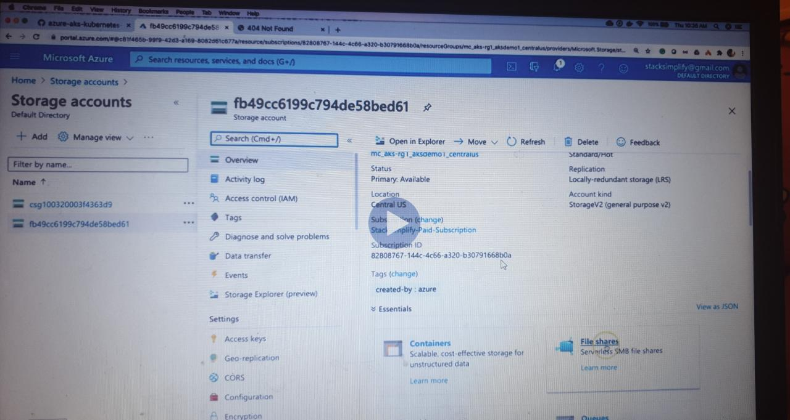
* 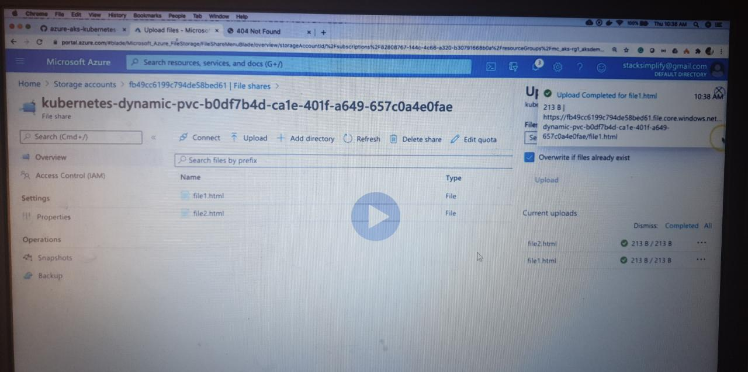
* 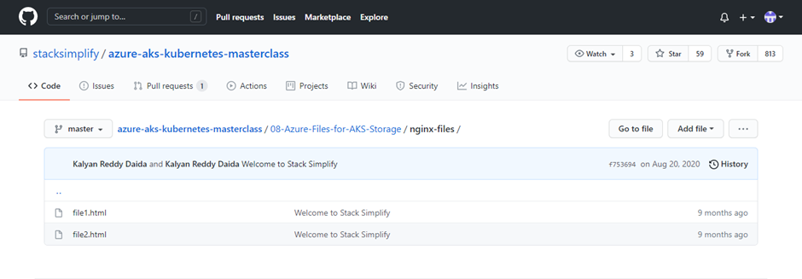

**Step-05: Access Application & Test**

# URLs

http://<External-IP-from-get-service-output>/app1/file1.html

http://<External-IP-from-get-service-output>/app1/file2.html

**Step-06: Clean-Up**

# Delete

kubectl delete -f kube-manifests-v1/

**Step-07: Create or Review kube-manifests-v2 and Nginx Files**

* Kube Manifests
  + 01-Persistent-Volume-Claim.yml
  + 02-Nginx-Deployment.yml
  + 03-Nginx-Service.yml
* nginx-files
  + file1.html
  + file2.html

**Step-08: Deploy Kube Manifests V2**

# Deploy

kubectl apply -f kube-manifests-v2/

# Verify SC, PVC, PV

kubectl get sc, pvc, pv

# Verify Pod

kubectl get pods

kubectl describe pod <pod-name>

# Get Load Balancer Public IP

kubectl get svc

# Access Application

http://<External-IP-from-get-service-output>

**Step-09: Upload Nginx Files to Azure File Share**

* Go to Storage Accounts
* Select and Open storage account under resoure group **mc_aks-rg1_aksdemo1_eastus**
* In **Overview**, go to **File Shares**
* Open File share with name which starts as **kubernetes-dynamic-pv-xxxxxx**
* Click on **Upload** and upload
  + file1.html
  + file2.html

**Step-10: Access Application & Test**

# URLs

http://<External-IP-from-get-service-output>/app1/file1.html

http://<External-IP-from-get-service-output>/app1/file2.html

**Step-11: Clean-Up**

# Delete

kubectl delete -f kube-manifests-v2/

**References**

* <https://docs.microsoft.com/en-us/azure/aks/azure-files-dynamic-pv>